**Rhythmic Tune – Project Report**

**1. Project Details**

* **Title:** Rhythmic Tune – AI Powered Music Generator
* **Team ID:**NM2025TMID44257
* **Team Leader:** Sathya.R&sathyankr35@gmail.com
* **Team Members:**
  + Brundha.G&brudhankrbrudhankr@gmail.com
  + Arthi.S&nkrcsarthi@gmail.com
  + Abinaya.P&nkrcsabinaya@gmail.com

**2. Abstract**

Rhythmic Tune is an AI-based project that generates unique rhythmic beats and music based on user input such as mood, genre, or tempo. It combines machine learning, music theory, and user customization to create an engaging and creative music experience.

**3. Objectives**

* To build an AI system that generates rhythmic music patterns.
* To allow users to customize tunes based on mood/tempo.
* To provide an interactive UI for listening, saving, and sharing music.

**4. System Requirements**

* **Hardware:** Minimum 4GB RAM, Dual-core processor, 10GB free disk space
* **Software:** Python 3.10+, Node.js, MongoDB, TensorFlow/Keras, React.js

**5. System Architecture**

**Modules Used:**

1. **User Module** – Registration/Login, Profile management
2. **Music Generator Module** – AI rhythm creation, tempo adjustments
3. **Playlist Module** – Save, manage, and share generated tunes
4. **Admin Module** – Manage users and monitor system performance

**6. Methodology**

1. Collect music dataset with beats and rhythms.
2. Train AI model (LSTM/RNN) for rhythm pattern generation.
3. Build Flask backend to connect AI model with frontend.
4. Develop React.js UI for users to interact with the system.
5. Store generated tunes and user data in MongoDB.

**7. Implementation**

* **Frontend:** React.js (UI with music player & controls)
* **Backend:** Flask/Django for AI model integration
* **Database:** MongoDB to store users, playlists, and generated files
* **AI Model:** LSTM-based rhythm generator using TensorFlow/Keras

**8. Results**

* Successfully generates rhythmic tunes in real time.
* Users can adjust mood, tempo, and genre.
* Tunes can be saved, replayed, and shared.

**9. Advantages**

* Creative AI-based music generation.
* Supports customization by mood & genre.
* Easy to use with interactive UI.

**10. Limitations**

* Limited to rhythmic tunes (no lyrics yet).
* May require high system resources for long audio generation.

**11. Future Enhancements**

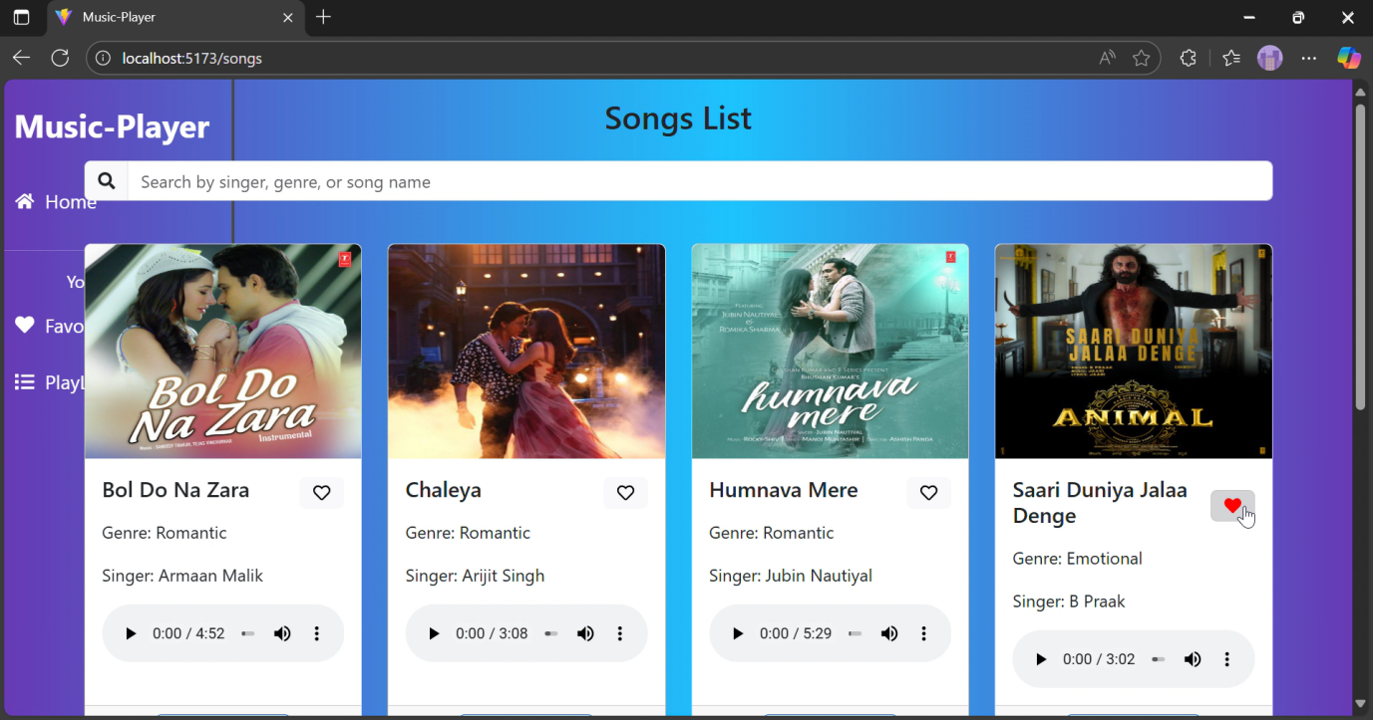

**12. Conclusion**

Rhythmic Tune demonstrates how AI can be applied in the music industry to generate rhythmic patterns and tunes automatically. This project shows innovation in combining AI with entertainment, making music creation more accessible.

Top of Form

Bottom of Form